**PROGRAMMING LANGUAGES COURSE**

**PROJECT REPORT**

**OUR PROGRAMMING LANGUAGES ;**

**FE-EF**

**PREPARED BY;**

**ESMA ÇELİKTEN 160316043**

**FATMA KURTULUŞ**  **170316064**

**OUR PROGRAMMING LANGUAGES**

**NAME İS : FE-EF**

**Goals;**

We will do the our programming languages. This languages will be Turkish.

**This programming languages;**

To write the values we write in a text in the C programming .

In C program work our programming languages. Therefore, we need to define our programming language in the C programming language.

**Comparing two programs;**

|  |  |
| --- | --- |
| C PROGRAMMING LANGUAGE | **OUR PROGRAMMING LANGUAGE (FE-EF)** |
| INDENTIFIER | **TANIMLAYICI**  **(TURKISH CHARACTER)** |
| UNSIGNED INTEGER (int) | **Tam** |
| UNSIGNED CONSTANT | **PSabit** |
| CONSTANT | **Sabit** |
| VARIABLE | **Kararsız** |
| RETURN | **Rapor** |
| Function | **Fonksiyon** |
| Parameter list | **Parametre listesi** |
| Array | **Dizi** |
| Size | **Ebat** |
| Loop (for) | **Takla (Zira)** |
| if | **Buysa** |
| then | **bu** |
| else | **yoksa** |

|  |  |
| --- | --- |
| ( | **[** |
| ) | **]** |
| *’’mutiplication’’ | **\*** |
| / ‘’Division’’ | **|** |
| + ‘’Addition’’ | **+** |
| - ‘’Extraction process’’ | **-** |
| < ‘’small’’ | **<** |
| > ‘’big’’ | **>** |
| = ‘’equal’’ | **=** |
| =! ‘’ not equal’’ | **!!** |
| /* ‘’comment row (start)’’ | **\*\*** |
| */ ”(finish)” | **\*\*\*** |
| , “comma” | **:** |

* Our programming language must start with letters.

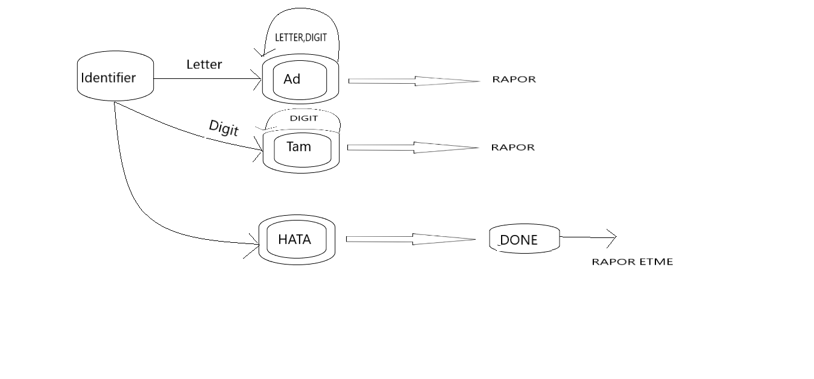

* We define values (Tam, PSabit, Sabit) in the function. We ensure that these values are work. The parameter list (parametre listesi) consists of functions.
* Tam 🡺memory space 2-4 byte

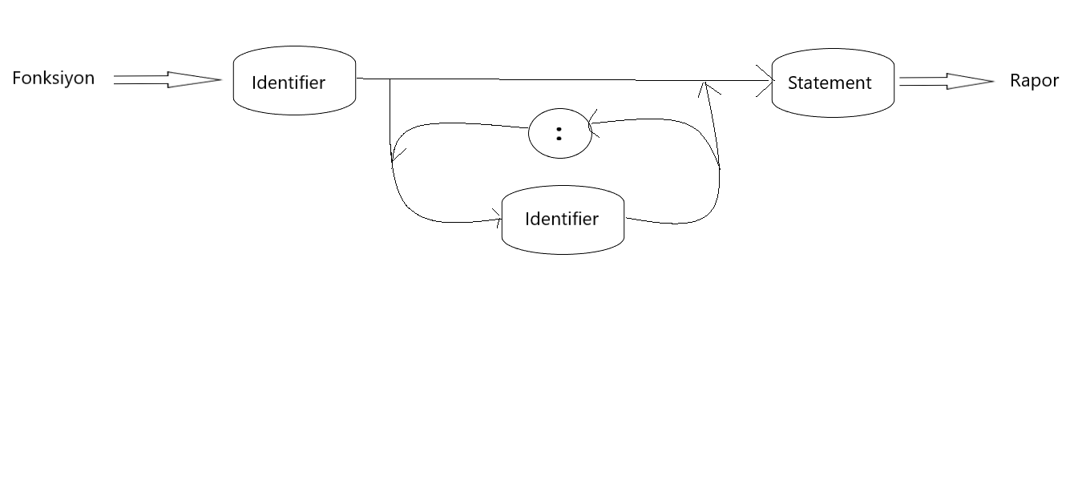

* In FE-EF programming languages ,loop (Takla);

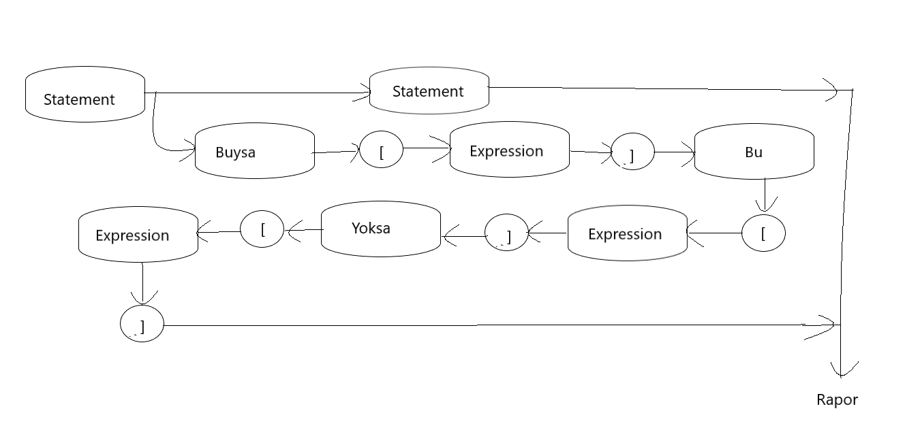

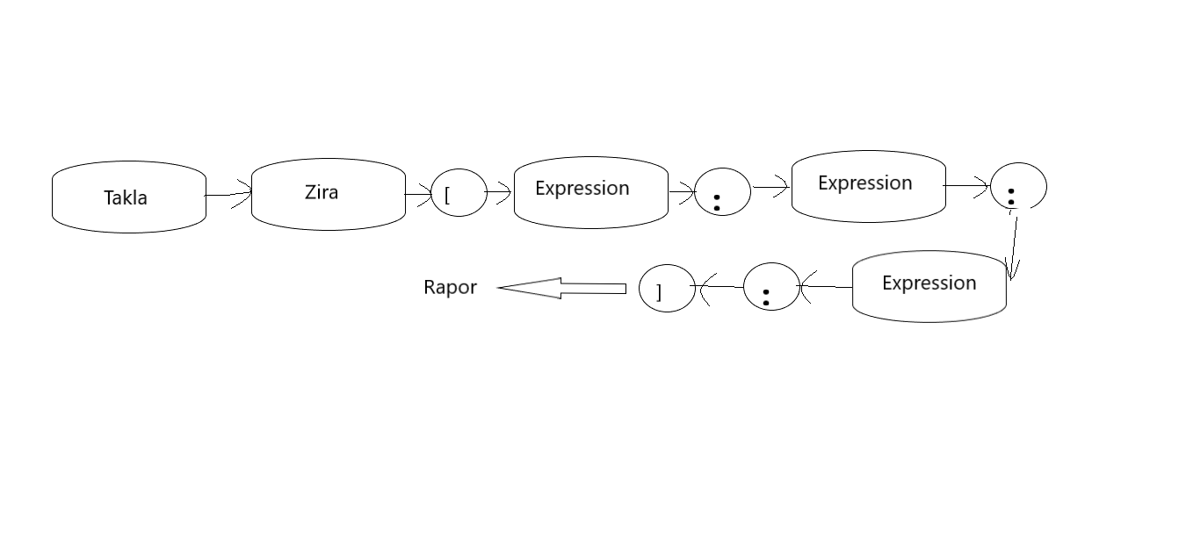

* Ex;

In C program In FE-EF program

🡺for (int i=1;i<10;i++) 🡺 Zira [Tam t=1:t<10:t++]

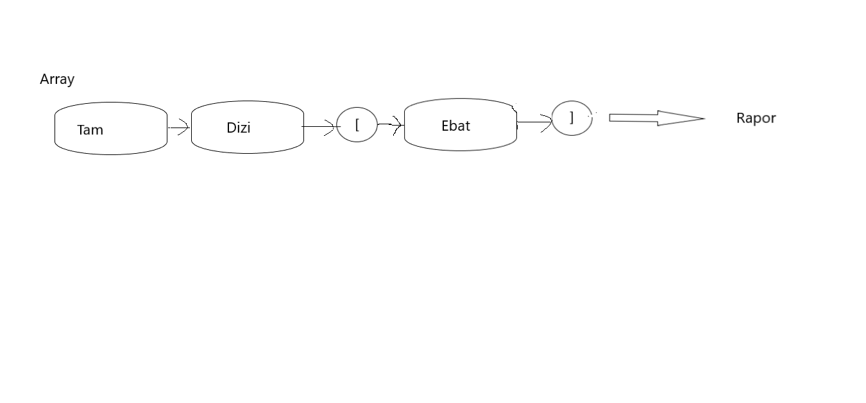

* Ex;

In c program In FE-EF program

🡺int array[size]; 🡺Tam Dizi[ebat]

🡺int array [3]; 🡺Tam Dizi[3]

🡺int array [3]=(10,20,30); 🡺 Tam Dizi[3]=[10:20:30]

* The size of the Dizi is to Ebat.

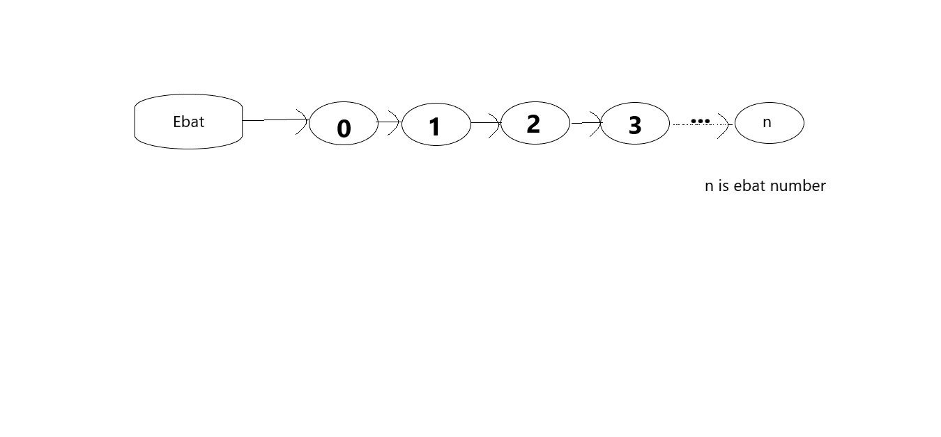

* Rapor is returns the desired value at the end of the process.
* Variable define:

Değişken ex; Tam a=5

* Blook define 🡺 [ … ]
* Compound expression; make multiple transactions.

Ex; [1+3]*5

* Simple expression; make a transaction.

Ex; [2+3]

* Statement; Assign a value to a character.

Ex; Tam a=6

* Upper case not equal lower case. Letter sensitivity.

(A!!a)

**LEXİCAL ANALYSIS**

In the lexical analysis section, we print the contents of the programming language that we write individually. And whichever identifier or integer (etc.) shows us this.

Screenshot of our output:

